Getting Your DH WebEx Host Account and Using WebEx
The following pages will show you how to use the DH WebEx web conferencing tool. This tutorial will cover the key “basics” for using WebEx as a Host and “extras” will follow. Make sure you understand the basics first before reading about the extras.
Once you have reviewed this document, go to https://dhvideo.webex.com/mw3000/mywebex/register.do?siteurl=dhvideo
Checkmark MEETING CENTER when signing up for your account.
Scheduling a WebEx Meeting – There are two ways to schedule your WebEx meeting; using your account located at https://dhvideo.webex.com or, the recommended way, downloading Productivity Tools from your account and scheduling WebEx meeting via Outlook. Step by Step directions follow. Save and refer to these once you get your official DH WebEx account.
Schedule your meeting in Outlook just like any other meeting; give it a title, start and end time, and create your invitation list. Before you save it, click on Add WebEx located on the Tool Bar at the top of the screen.
All Scheduled WebEx meetings need a password. It must be 6 characters long with at least one capital letter and one number. DO NOT use your personal WebEx account password as you meeting password.
Once you’ve created the password, you can assign another individual(s) to be an Alternate Host. An Alternate Host can start the meeting in your absence (Otherwise, no one can start your meeting.) An Alternate Host MUST HAVE a DH WebEx account. Click on resources and check-mark the name of the individual(s) listed in the box. This list was generated by your e-mail invitation list.
Click Save and Send. The meeting information will go into you Outlook calendar. Individuals invited will receive an e-mail with information pertaining to them.
DO NOT SHARE YOUR WEBEX INVITE INFORMATION. As Host, this info is for you. WebEx is a secure application, so for instance, if you have started your meeting, and someone else tries to join using your info, they will not get into the meeting!
Starting Your Meeting – THIS IS VERY IMPORTANT. Never start your WebEx meeting from within DHApps or Citrix. This application will block all or part of your WebEx session. If people complain that they cannot see what you are Sharing, you are probably running WebEx from within Citrix. Always start your WebEx right from your browser. Internet Explorer, Firefox, Chrome and Safari all should work.
Normally, clicking on the link in your calendar will start your WebEx. An alternative is to log into your DH WebEx account at https://dhvideo.webex.com and find your meeting (under My Meetings, duh.) Then click Start.
You may be prompted to “Run” the application a few times, this is normal depending on security settings. You should be in your WebEx session within a few seconds and your screen will look something like this.
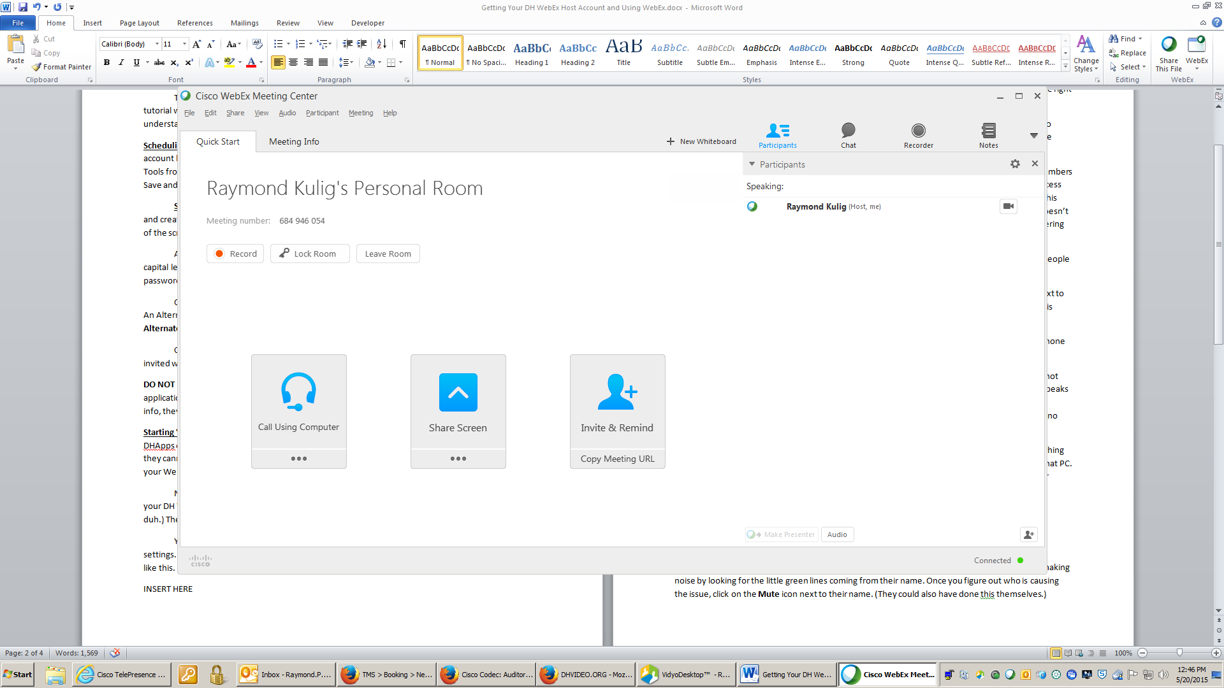
Once you have joined the WebEx session, it is now time to join by audio. You have three choices. The default is by Call Using Computer (also known as VoiP.) Use this ONLY IF YOUR COMPUTER has the right resources for good audio.
If you are in a conference room, use a conference phone. You now have two choices left to connect by audio. The first is to have the WebEx Call Me. If you know the telephone number to the speaker phone in the room enter the number. The phone will magically ring. Answer it!
If you do not know the telephone number, click on I Will Call In. The toll free and other numbers as well as Access Code and User ID are located here. Once you connect, WebEx will ask for the Access Code. Enter it. Then it will ask for your User ID. Enter this too. While you can join by not entering this unique ID that is on your screen, doing so will make you a “Call In User # xxx.” Basically, WebEx doesn’t know who you are but lets you in because you had the correct Access Code. We recommend entering your User ID though.

What Am I Seeing On The WebEx Screen? – First, look to your right. You’ll begin to see all of the people who have joined the WebEx meeting.
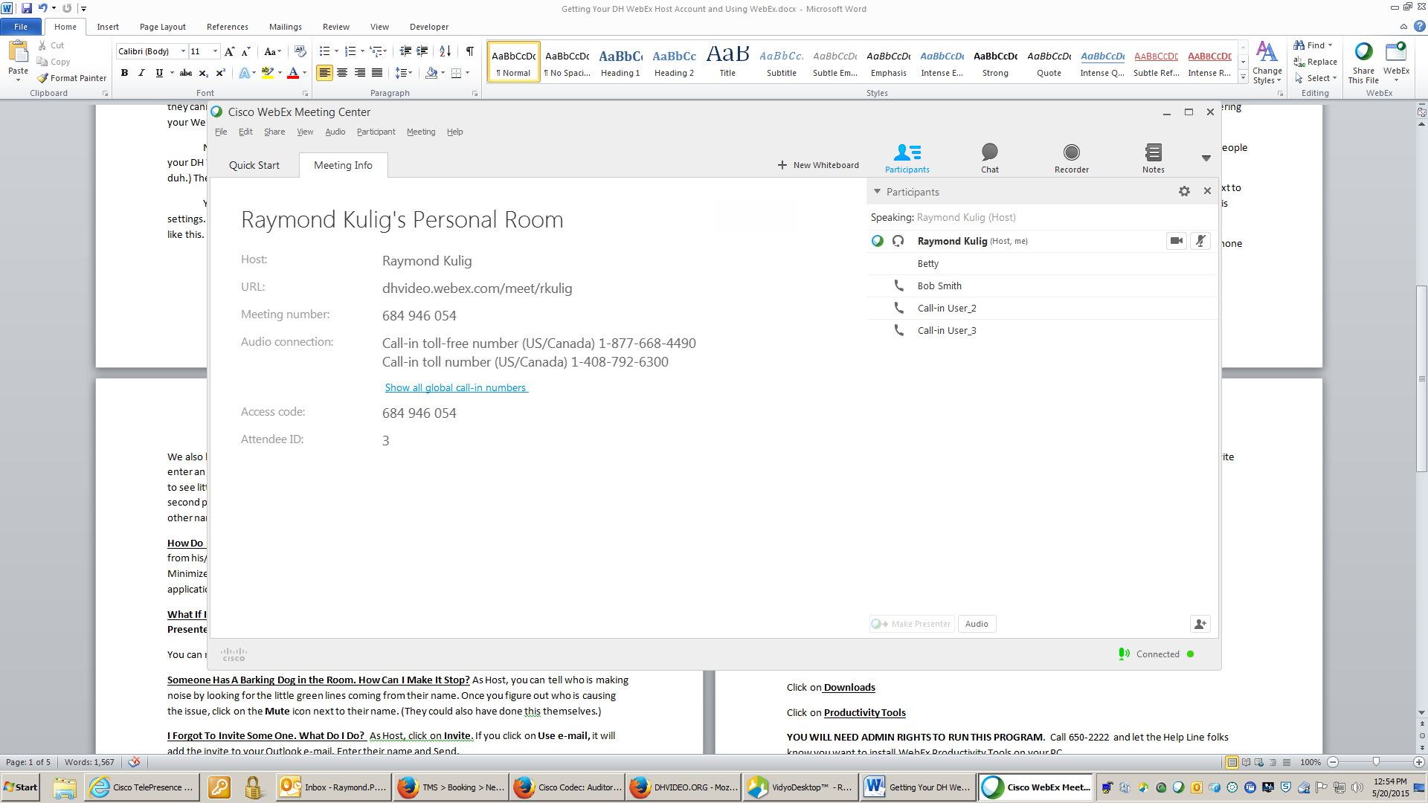
In our example, we have Ray and he is the Host (you can tell because the word HOST is located next to his name!) He is also connected by VoiP. You can tell because he has a little headset icon next to his name.
We also have Bob Smith. He is connected by telephone. You can tell because there is a little telephone icon next to his name.
We also have Betty. There is no icon next to her name. She either has not yet called in, or she did not enter an ID when she called. She could be Call In User # 2 or 3. We won’t know for sure until she speaks to see little green lines appearing next to the icon. Since we have two “Call in Users…”, we have a second person who called in without using their ID. This other person is in just by telephone since no other name appears in the Participant List.
How Do I Share Stuff From My Screen? By default, the Host is also the Presenter. To Share something from his/her PC or Mac, simply click on the Share Screen icon. Now everyone can see what is on that PC. Minimize anything you don’t want or need people to view. Open up any PowerPoint, document or application you want people to see.

What If I Want Someone Else to Share? – That’s easy, just click on their name and click on Make Presenter located near the bottom of the participant list. Now they can Share.
You can make anyone at any time a presenter.
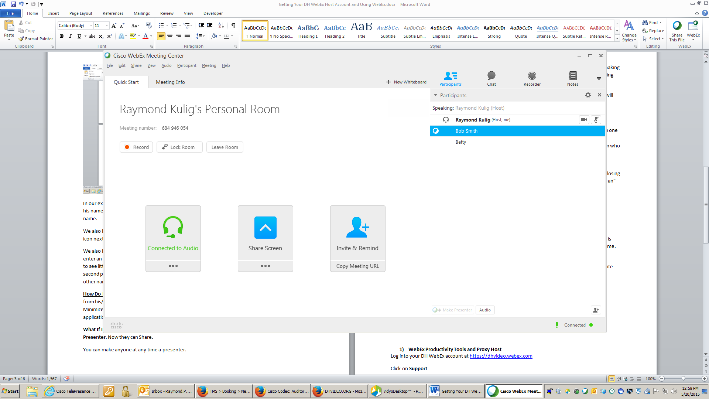
Someone Has A Barking Dog in the Room. How Can I Make It Stop? As Host, you can tell who is making noise by looking for the little green lines coming from their name. Once you figure out who is causing the issue, click on the Mute icon next to their name. (They could also have done this themselves.)

I Forgot To Invite Some One. What Do I Do? As Host, click on Invite and Remind. If you click on Invite with your local e-mail, it will add the invite to your Outlook e-mail. Enter their name and Send.
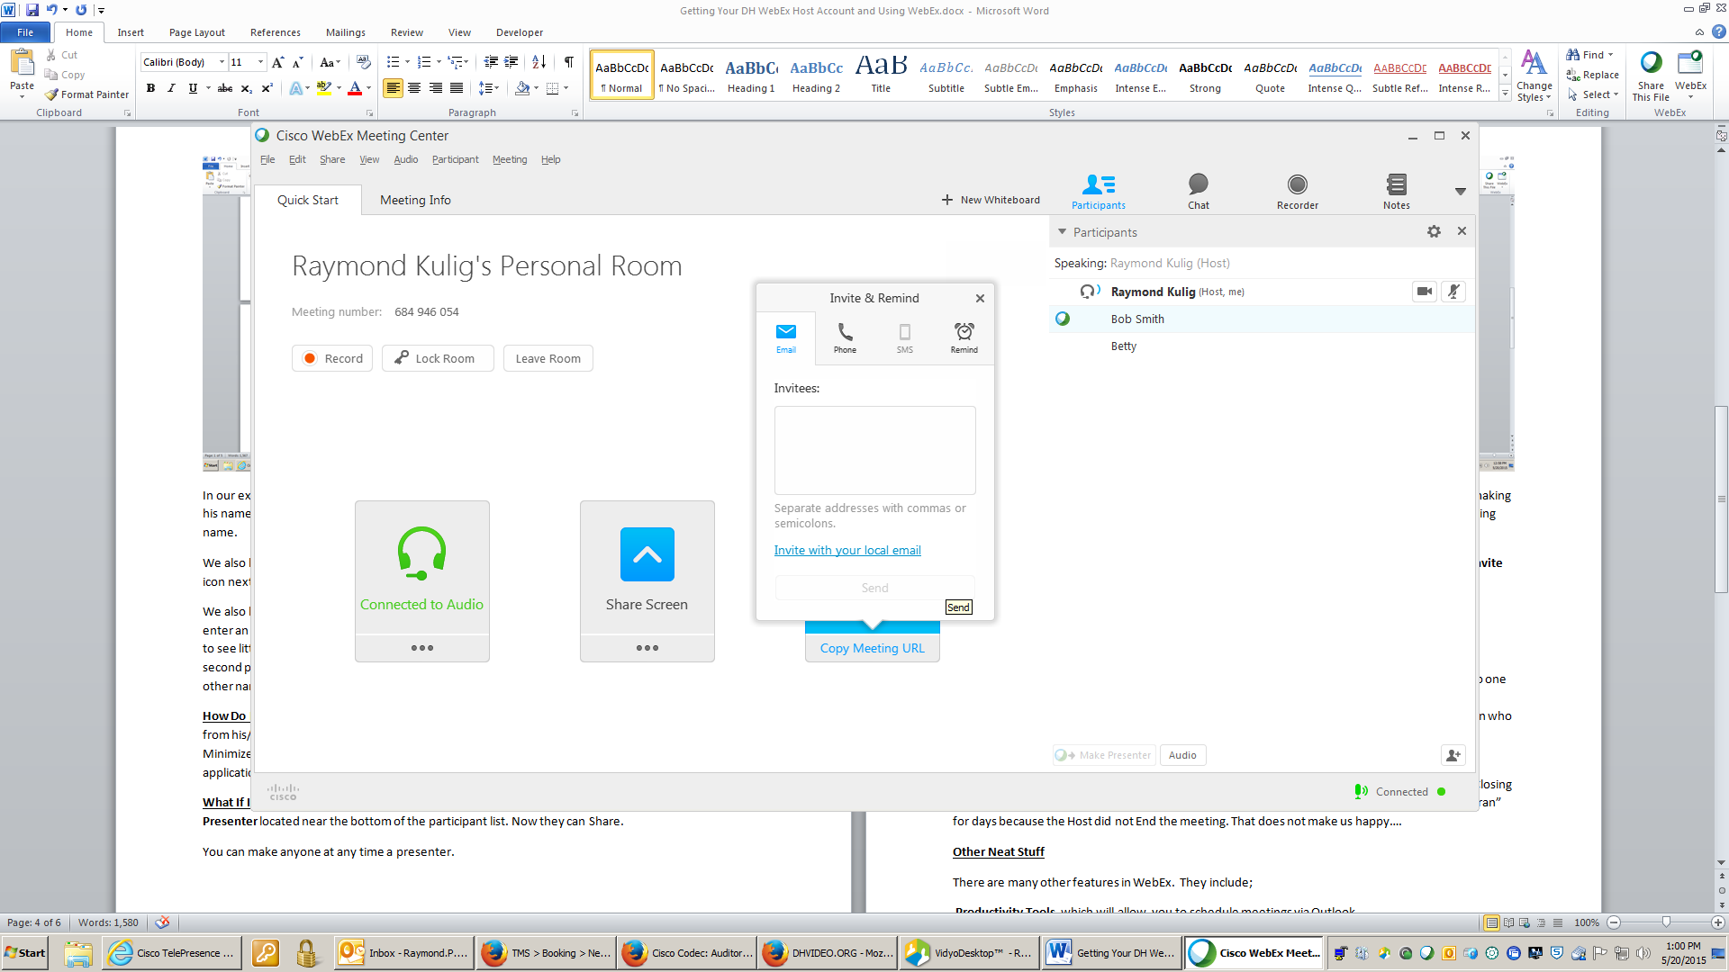
Can I Record The Meeting? Yes, just click on the Record Icon. READ THE FOLLOWING.
Make sure that you are recording by observing the little elapsed time clock.
Record only to the WebEx Server, not to your PC. Remind people that they are being recorded, no one likes surprises!
The recording will end up in the My Recorded Meetings folder in the WebEx account of the person who was the Original Host (Not the Alternate Host.) Most recordings are available 1-2 hours after your meeting ends.

What if I need to leave the meeting? Unless you click on another member in the WebEx and then (right click on the mouse) make them a Host your meeting will end. Also remember, that if you are in the same room as your new host, and using the same telephone, the phone connection will drop. The new Host will need to re-establish the connection.
How Do I End My Meeting? Go to File and Leave Room. Make sure to end the meeting for all. Closing your laptop does not always end the meeting. There have been a few instances of meetings that “ran” for days because the Host did not End the meeting. That does not make us happy….
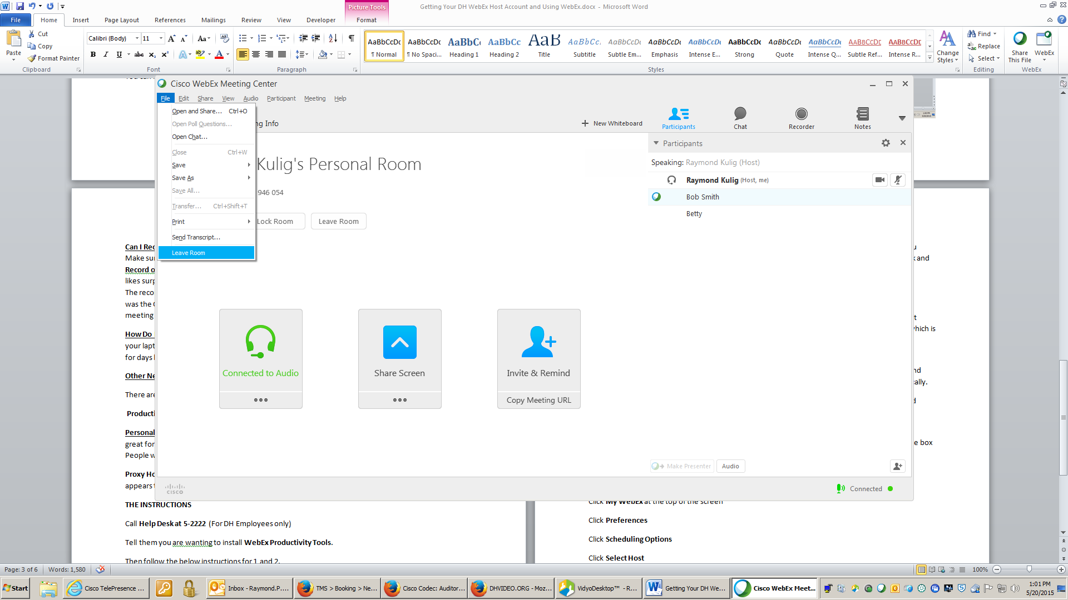

Other Neat Stuff
There are many other features in WebEx and they include the following.
Productivity Tools which will allow you to schedule meetings via Outlook.
Personal Meeting is a neat feature letting you start an meeting right away without scheduling it. This is great for last minute things. You can send a simple url to people and the password is always the same. People will wait in a “waiting room” until you join making it very secure.
Proxy Host allows your administrative assistant to schedule WebEx meetings on your behalf. The invite appears to come from and goes into your calendar.
The Instructions For Installing Productivity Tools
Call Help Desk at 5-2222 (For DH Employees only)
Tell them you want to install WebEx Productivity Tools.
Then follow the below instructions for 1 and 2.

- WebEx Productivity Tools
Log into your DH WebEx account at https://dhvideo.webex.com
Click on Support
Click on Downloads
Click on Productivity Tools
YOU WILL NEED ADMIN RIGHTS TO RUN THIS PROGRAM. Call 650-2222 and let the Help Line folks know you want to install WebEx Productivity Tools on your PC.
Once you have admin rights, run the program.
The URL will be https://dhvideo.webex.com Enter your DH WebEx username and password. (If you forgot your password click on Remember My Password Select Apply and OK. ) Then close Outlook and restart it. You should see the Add WebEx icon in the meeting toolbar.
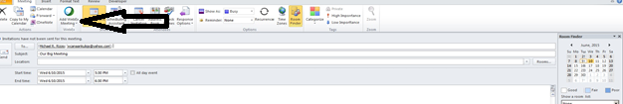

- Setting Up Personal Meetings
An Instant Meeting is also known as a One Click Meeting. It allows people to start a meeting “right now” without the need to schedule the meeting in advance. WebEx also has My Personal Room which is the same thing as an Instant/One Click Meeting but uses a more standard web url such as https://dhvideo.webex.com/debbiesmith
The advantage to the Personal Room other than a simpler url is that people can click on the link and wait until the host joins the meeting at which time they are “dumped” into the meeting automatically.
Both the Instant Meeting/One Click meeting and the My Personal Room use a common name and password. DO NOT USE YOUR DH WEBEX PASSWORD as your meeting password. Use something unique and easy to remember. To create this capability, choose “Meet Now” Settings (sometimes called Instant Meeting) and enter the name of the meeting and password. Click Apply.
If you decide to use My Personal Room as your default instant meeting application, check mark the box “Use My Personal Room for Instant Meetings.”

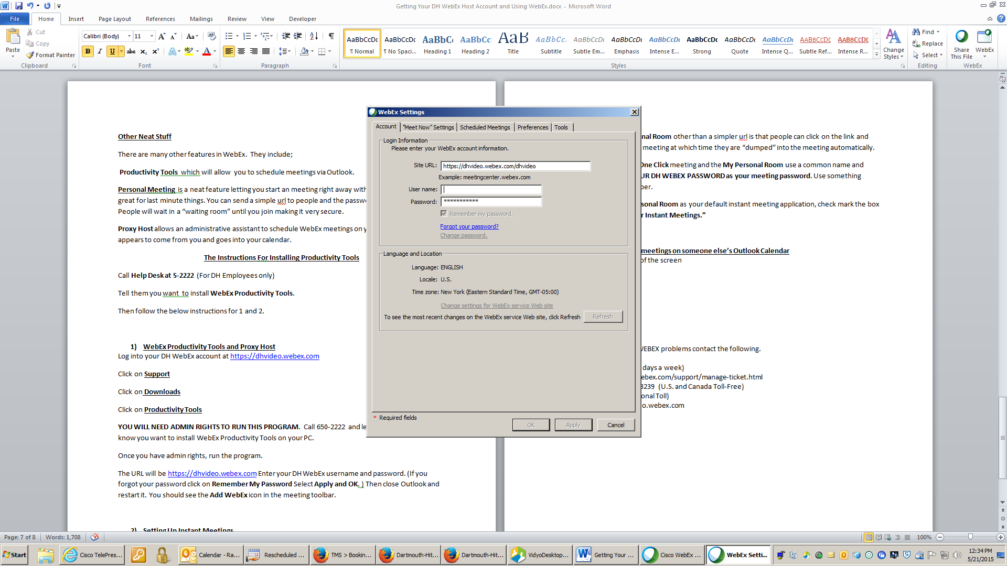

- Proxy Host-Scheduling WebEx meetings on someone else’s Outlook Calendar
The individual for whom you schedule for in Outlook must go to https://dhvideo.webex.com and log into THEIR account. Then they will;
Click My WebEx at the top of the screen
Click Preferences
Click Scheduling Options
Click Select Host (under Scheduling Permissions)
Click Save
Remember, you must be listed as having permission in the other person’s Outlook account and their WebEx account for this feature to work.
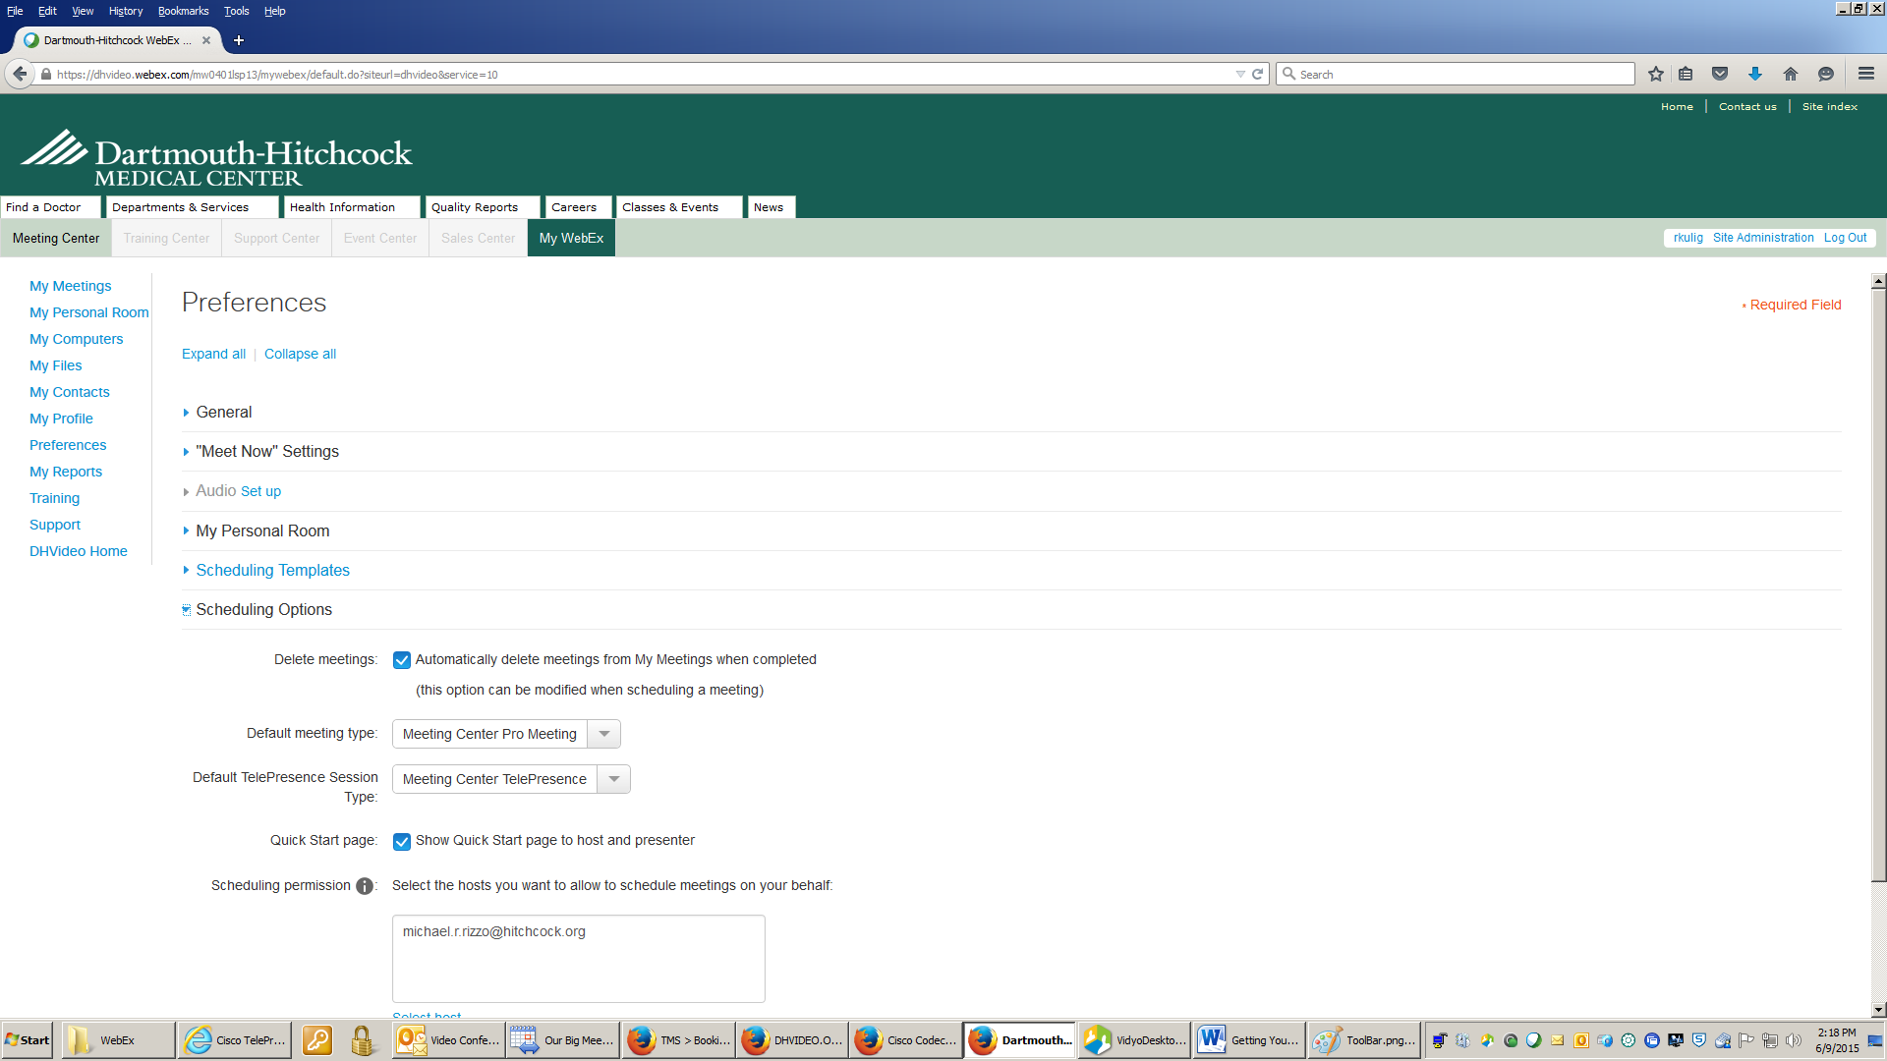

Technical Help - FOR ANY WEBEX problems contact the following.
WebEx Technical Support
(Available 24 hours a day, 7 days a week)
Contact: https://support.webex.com/support/manage-ticket.html
Phone: 1-866-229-3239 (U.S. and Canada Toll-Free)
+1-408-435-7088 (International Toll)
DHMC WebEx site is dhvideo.webex.com

WebEx also offers several short, easy to follow tutorial videos for WebEx. They are located at http://www.webex.com/how-to/index.html
Note: Some of the videos may show features and capabilities that are slightly different than the DH WebEx offerings

